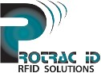
Forklift Safety Case Study: Recycling Facilities
Protrac ID Australia P/L
Unit 7, 3972 Pacific Hwy Loganholme QLD 4129 Ph: +61 7 3806 3224

A leading, privately owned packaging and resource recovery company, with more than 120 sites across Australia, New Zealand, Thailand and Vietnam and trading offices across Asia, Europe and the USA.

What were the risks?
A number of potential risks for serious injuries caused by the continuous interaction of workers, delivery trucks and forklifts.
The risks were that:
- Forklift drivers and pedestrians were working together in a confined space, leading to an increased risk of injury
- Forklift drivers were exposed to weather and had to operate forklifts on wet and slippery surfaces
- The view from the forklift driver is often obstructed, preventing clear sight of interactions with pedestrians, delivery trucks and forklifts

What were the solutions?
Management recognized that they needed to make changes to its safety management plan across sites. The changes included:
- Creating designated truck parking zones using floor line markings to ensure adequate space between forklifts and delivery trucks
- Installing Protrac ID Forklift Alert Systems to all forklifts creating a clear zone between forklifts and pedestrians
- Consulting workers from the beginning of the process so they understood the new management plan
- Providing ongoing support for the changes

What were the benefits?
- Loading trucks in designated areas reduced the need for pedestrians to be within the area
- Visibility from the forklift drivers was improved through installation of Protrac ID Forklift Alert System, allowing Forklift drivers to identify pedestrian movements in all areas
- Involving workers in the development of the plan gave them a greater ownership of their own safety
- Reporting and awareness of safety issues improved as workers were empowered to report incidents and near misses

Protrac ID FAS System
- Protrac ID FAS unit is fitted to the forklift truck
- Workers are issued with Protrac ID safety vests and/or tags
- Drivers receive a warning when a tag has entered the detection area around the forklift
- Driver warnings include strobe light and piezo alarm as standard
- Acceptance feature available for driver to use at his / her discretion
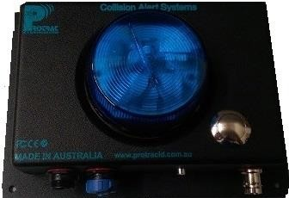
- Waterproof system including tags

This case study is only one example of the solutions manufactured by Protrac ID to deliver cost effective
communication solutions to customer’s problems. If you require help in this complex field, make sure Protrac ID is the first company you contact.

