Application – Patient Wandering Products – AssetTrac – 2R5000 – 2R2000
Protrac iD in 2000 pioneered the development of Active RFID in Australia. Working with Customers and System Integrators worldwide, Protrac iD have engineered and developed innovative and industry leading Solutions and Products for a wide range of applications. To reduce the risk and increase patient safety, Protrac Id developed a product for Real Time Tracking and Monitoring of patients.

Many large health facilities face the problem of accurately monitoring patient movements throughout a facility. This is vital for the safety of patients, staff and visitors. Historically, sites have relied on staff to physically monitor and check the whereabouts of individual patients, thus allowing room for human error. An increase in staffing numbers to accommodate these additional work practices leads to higher running costs and less profitability.
Restrictive practices have been utilised throughout the industry in years gone by, however, the National Framework guidelines now state that Policies, procedures and tools should protect the rights of people with disability, focusing on improving clients’ quality of life, and reducing and monitoring the use of restrictive practices.

‘Protrac ID have provided a system which is really easy for staff to work with. The support we receive from them is exceptional.’

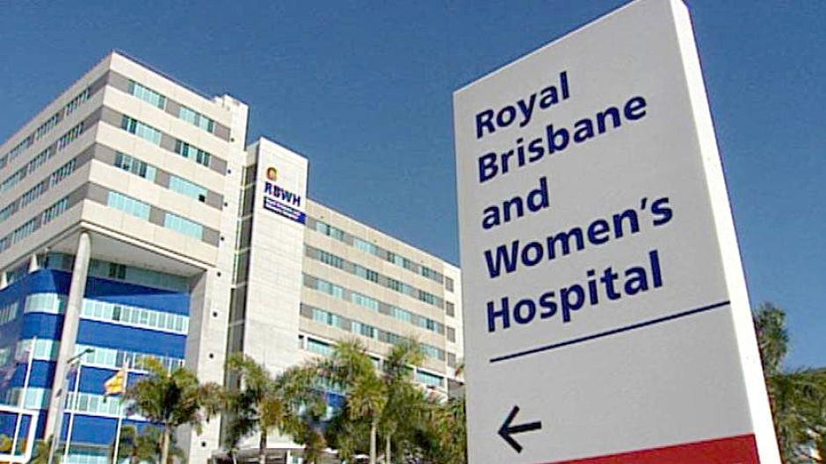
Protrac ID worked closely with Seadan Security and ARA Group to design and implement a system that enables patient movements to be monitored and displayed at individual nurse’s stations.
Each patient is allocated a bracelet tag which is recorded into a database along with the patient’s personal details. As the patient moves throughout the facility their location is displayed on screens located at all nurse’s stations. When patient’s approach a monitored exit, an alarm will be triggered and their location is pin pointed on the floor maps alerting staff to the patient’s location.
Christopher Aynsley – Hartwell, the Facilities Maintenance Manager says “Protrac ID have provided a system which is really easy for staff to work with. The support we receive from them is exceptional”

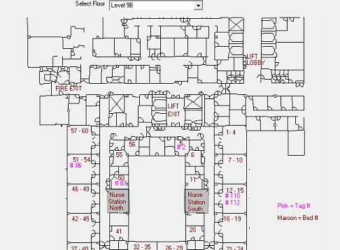
- Royal Brisbane Women’s Hospital
- Levels 6, 7, 8, 9
- Wards 6A, 6B, 7A, 7B, 8A, 8B, 9A, 9B
- 190 x 2R2000 Receivers (location receivers)
- 37 x 2R5000 Receivers (Alarm & location receivers)
- 227 x Patch antennas
- 120 x Bracelet Tags (Patients)
- 20 x Bracelet Tags (Staff)
- 1 x PC Headend
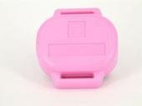
- 1 x AssetTrac Software & Babyguard module
- 8 x 2PCI200 Gateways
- 8 x Client software modules
- Design & Commissioning

