High Security Wireless Mobile Duress System

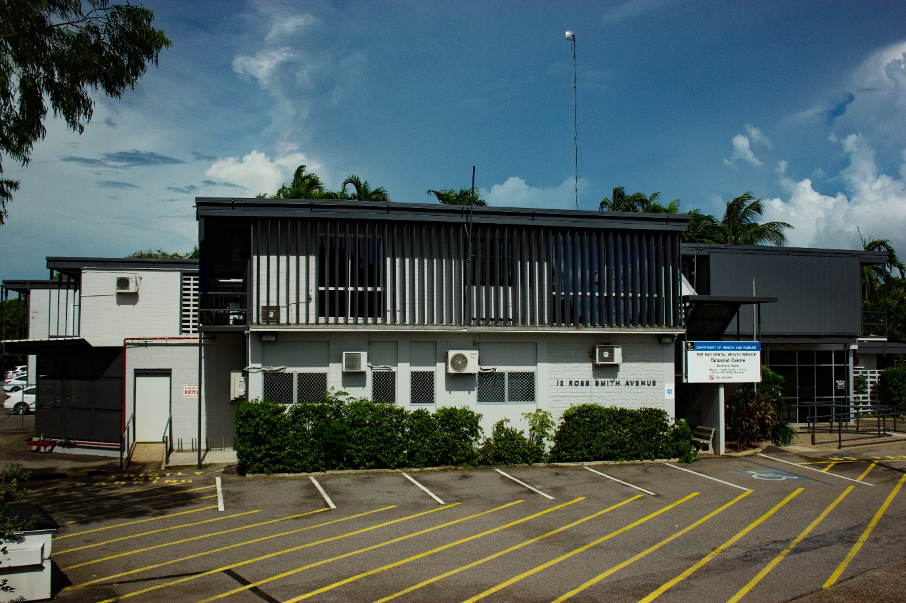

Security & Technology Services completes advanced Wireless Duress installation at the Tamarind Centre Health Clinic Complex in Darwin.

Healthcare workers are at high risk of assault by patients suffering from mental illness, drug and alcohol abuse. System that provide Life-saving alarms to alert security and site personnel quickly, safely and efficiently of threats or potential violence are critical to protecting personnel in high risk environments.

In April 2017 Security & Technology Services (STS) was awarded a contract by the Northern Territory Government to provide an advanced wireless duress and tracking system for the safety of health workers and staff at a health complex in Darwin. The existing wireless duress system at the centre was replaced with a solution by Protrac iD, which included Protrac iD AssetTrac software and networked RFID readers to monitor 3-in-1 Duress/Id cards carried by staff.

The solution provides Real Time Locating System (RTLS) that keeps track of the current location of Protrac iD tags carried by and associated with individual personnel, provides duress alert functionality through an integrated duress button within the tag and can also be used as the primary ID card for security access control systems.

The system assists in protect personnel by providing them with the ability to alert others that they’re in trouble and need assistance. The system will initiate audible and visual alarms and provides a Real-Time location of the person in trouble on a display monitored site map of the building as well as having the capability to send emails or SMS messages with the location details. The real time tracking of functionality also provides valuable information as the location of personnel during an evacuation or site-wide threat. The system can be configured to provide voice alarm systems including the location of personnel in trouble.
With the support of Protrac iD, STS have received great feedback from management onsite in regard STS’s personnel and the performance of solution.
STS are an approved Protrac iD partner. (Security & Technology Services (STS) are part of the Optic Security Group)

